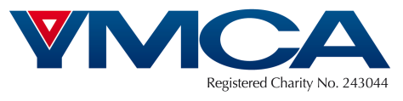

Commercial Assistant: Supplementary Questions

Please answer the below questions and submit them, with your application form, to recruitment@nottsymca.org

- Do you have a car?

- Please provide a brief explanation of what relevant experience you have to fulfil this job?

- What kind of environment do you thrive in?

Nottinghamshire YMCA is committed to promoting diversity and practicing equality of opportunity
Nottinghamshire YMCA is committed to the protection of children and vulnerable adults

